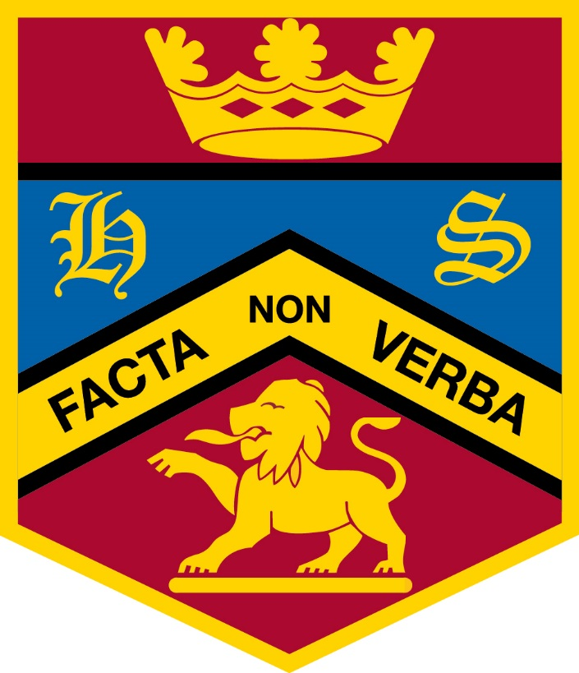
Highclare School

Lunchtime Supervisor /Cleaner
Job Description
Job Purpose

Lunchtime Supervisors are engaged on a part-time basis to undertake supervision of pupils during the school’s lunchtime break.

Duties and Responsibilities:
- To be responsible to the Senior Lunchtime Supervisor for the supervision of pupils on the premises during the school's lunchtime break.
- To attend to any pupil who becomes sick or ill during the lunch hour, escorting pupils to the School Office if required.
- To report to the Senior Lunchtime Supervisor or teacher in charge if an accident occurs, or if any pupil has been taken ill.
- To mop up spillages as they occur within the dining rooms.
- To follow school procedures related to the administration of first aid and completion of ‘bump notes’
- To adhere to the ethos of the School:
  - To promote the agreed vision and aims of the School
  - To set an example of personal integrity and professionalism
  - At attend appropriate meetings and professional learning and development training days
- To carry out any other duties as commensurate with the grade in order to ensure the smooth running of the School.

Preparatory Schools only:
- To be in charge of a group of pupils in the playground or classrooms according to the weather.
- To attend to any minor accidents sustained during the lunch hour, escorting pupils to the School Office if required.
- To assist pupils with scraping their plates, clearing tables etc., when the lunch is completed.
- To observe confidentiality guidelines.
- To record any lunchtime incidents on CPOMS, if possible, or handwritten if not.
- To see that pupils taking school meals are in the dining room at the required time for lunch.
- To see that pupils wash their hands and attend to their necessary toilet requirements before and after lunch.
- To help younger pupils with the proper use of cutlery and with the cutting up of food when necessary.
- To ensure that pupils are escorted to and from detached dining rooms.

Senior School only:
- To encourage pupils to eat healthy meals.
- To clean tables and chairs after use and to maintain a clean and healthy environment.
- To mop up any spillages as they occur during the lunch break.
- To direct pupils to clearing station and ensure crockery and cutlery are fully cleaned and deposited in the correct place.
- To ensure the refectory is clean and tidy after lunch, including a thorough sweep of the floor.
This list is intended to be as comprehensive as possible, but is not exhaustive.

Highclare School is committed to safeguarding and promoting the welfare of its pupils. There is a legal requirement to provide satisfactory replies to List 99 enquiries which are obtained in the form of an Enhanced Disclosure from the Disclosure and Barring Service.
AMc/lh/Nov 20

